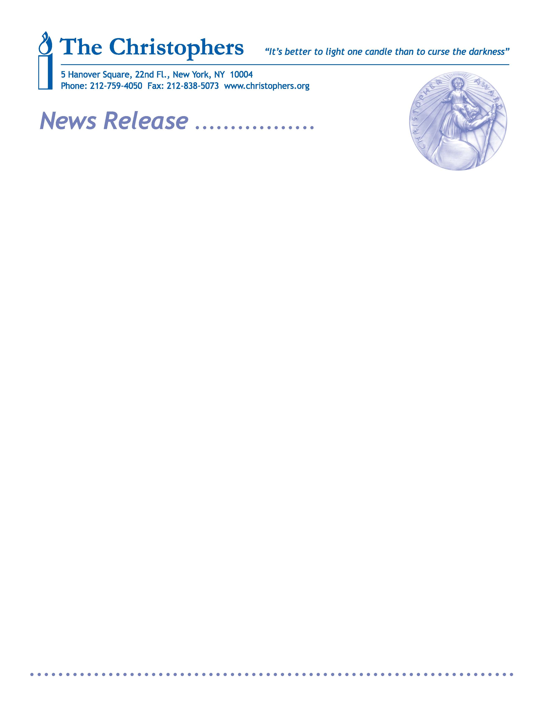

Contact: Jeanne Byington 212-140-5834; jeanne@jmbyington.com
David Reich 212-573-6000; david@reichcommunications.com

NEW YORK-BASED AUTHOR SALLY LLOYD-JONES & ILLUSTRATOR JEN CORACE, PROVIDENCE RI, HONORED BY A CHRISTOPHER AWARD FOR “BABY WREN AND THE GREAT GIFT"

The book, celebrated at The Christophers’ 68th annual gala May 16 in NYC, is one of 12 representing 16 authors and illustrators joining writers, producers and directors of nine feature films and TV/Cable programs

NEW YORK, March 28, 2017 –New York City-based bestselling author Sally Lloyd-Jones and illustrator Jen Corace, Providence, RI, have won a Christopher Award for “Baby Wren and the Great Gift," [Zonderkidz/Harper Collins Christian Publishing]. Written for preschool and up, it is one of 12 books for adults and young people by 16 authors and illustrators to be celebrated, along with the writers, producers and directors of nine feature films and TV/Cable programs, on May 16, 2017 at the 68th annual Christopher Awards in New York.
"Baby Wren and the Great Gift," is a celebration of all the wonderful gifts God has given us. The tiny wren marvels at the incredible creatures around her, all the while wishing she had a special gift to share. As she takes in the beauty of the world around her, she discovers a unique talent that’s been inside her all along.
Sally Lloyd-Jones is a leading writer of inspirational books for children. She is the author of three bestselling children’s Bibles, including the Moonbeam Award winner and ALA notable “The Jesus Storybook Bible,” as well as “Thoughts to Make Your Heart Sing,” winner of the ECPA Inspirational Book award. She has written many picture books for children, such as the critically acclaimed New York Times bestseller “How to Be a Baby: By Me, the Big Sister” and “Song of the Stars.” Sally was born and raised in Africa, was schooled in England.
Jen Corace is an artist and freelance illustrator responsible for many bestselling children’s books including "Little Pea," "Little Hoot," "Little Oink," "Hansel and Gretel," "The Steadfast Tin Soldier," and "Telephone." She has a BFA in illustration from the Rhode Island School of Design. The Christopher Awards were created in 1949 to celebrate authors, illustrators, writers, producers and directors whose work “affirms the highest values of the human spirit.” The Christophers, a nonprofit organization founded in 1945 by Maryknoll Father James Keller, is rooted in the Judeo-Christian tradition of service to God and humanity. The ancient Chinese proverb—“It’s better to light one candle than to curse the darkness”— guides its publishing, radio, and awards programs. More information about The Christophers is available at www.christophers.org.
###

